2025 TERM I MZIMBA NORTH DISTRICT EXAMINATIONS

FORM 1 GEOGRAPHY
(100 MARKS)
Date: Wednesday, 17-Dec-20225
Time Allowed: 2hrs
(7:30 to 9:30 a.m.)

INSTRUCTIONS:
- This paper contains 9 printed pages. Please check.
- This paper has three sections: A, B, and C. Answer all questions in all the sections.

- Follow instructions for each section carefully
- Hand in your question paper to the invigilator when time is called to stop writing.
IMPORTANT
Make sure you write your official name on the top on the spaces provided on all the pages of this paper before answering the questions.

@MZN-T1-2025

Section A (20 marks)
Answer all the questions by encircling the letter corresponding to the correct answer

- What is the order of the first planets from the sun?
  - Mercury, Venus, Mars and Earth
  - Venus, Mercury, Mars and Earth
  - Mars, Venus, Earth and Mercury
  - Mercury, Venus, Earth and Mars
- Hotels, game reserves and historical sites are shown on a ____________
- Tourist map
- Political map
- Topographic map
- Distribution map
- Which colour shows all water features on the map
- Green
- Black
- Blue
- Red
- Which statement is not true about large scale maps
- They have small denominators
- They show small area
- They represent large area
- They show more details
- The earth rotates from______
- North to south
- South to north
- West to east
- East to west
- Which of the following is not an example of a planet
- Venus
- Ceres
- Mercury
- Jupiter
- The spherical shadow on the moon takes place when
- Earth is between the sun and the moon
- Moon is between the sun and the earth
- Sun is between the moon and the earth
- Earth is between Venus and Mars
- The following are true about the shape of the earth except
- It is not a perfect sphere
- It has a slightly distorted shape
- It is round like a ball
- Slightly flattened at the top
- Earth’s complete rotation takes place for every
- 15◦
- 12 hours
- 24 hours
- 365 1/4 days
- When planets are close to the Sun in their elliptical orbit is known as:
- Perihelion
- Aphelion
- Eperihelion
- Ephelion
- People who make maps are called
- Cartographers
- geographers
- Drawers
- Demographers
- Which of the following is not an example of a small scale
- 1:252,000
- 1:251,000
- 1:249,000
- 1:253,000
- An economic map shows
- How land is used
- Information about places of interest
- Mining, farming and manufacturing
- Shapes of physical features
- The following descriptions are true about aerial photographs except:
- Shows actual features
- Pictures are taken from the air
- They are drawn to scale
- Shows every detail in an area
- The entering of water between soil particles is called
- Infiltration
- percolation
- precipitation
- transpiration
- solstice is the time of the year when the sun is
- Overhead the tropic of cancer
- Overhead the tropic of Capricorn
- stand still between its northward and south ward journey
- Overhead the southern tropic
- Which planet is also called “earth’s Twin”
- Saturn
- Mars
- Venus
- Uranus
- The following are features of the hydrological cycle except
- Transpiration
- Ground water
- Vegetation
- Water masses
- Reforestation means
- Planting trees where they are cut
- Planting trees where there are no trees
- Replanting an area with trees and grass
- Planting new trees in an area where once had no trees
- An atlas means the following except:
- A collection of maps
- A book of maps
- A book containing facts and history about certain places
- A book containing photographs

Section B (50 marks)
Answer all questions in this section in the spaces provided
- Figure 1 is a map of Sharpe Valley. Use it to answer questions that follow:
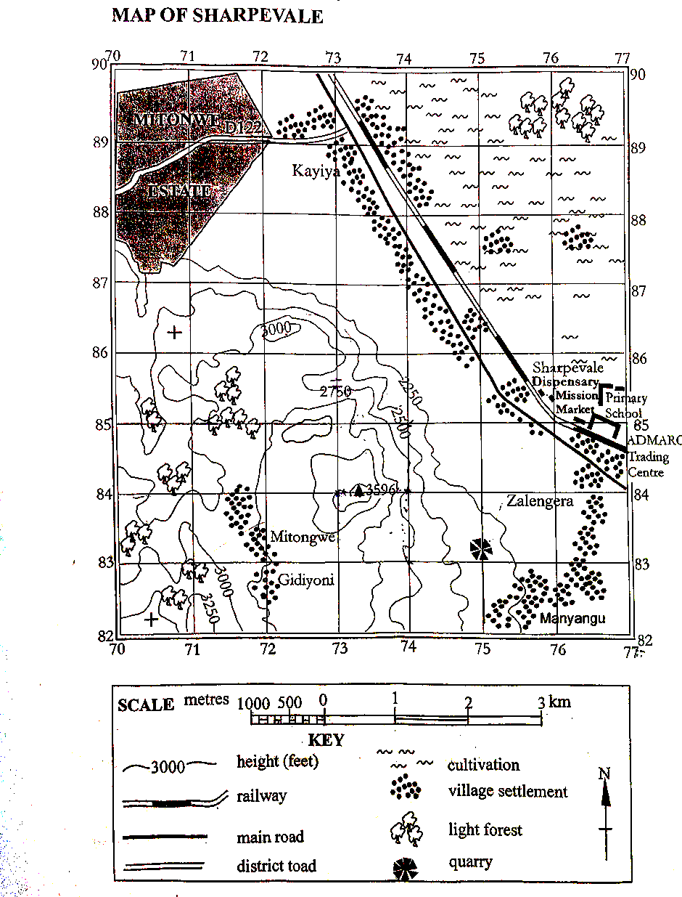

- Calculate the following on the map
- Four figure grid reference for the Dispensary
____________________________________________________________________1 mark
- Six figure grid reference for the trigonometrical station 3596
___________________________________________________________________2 marks
- In which direction is Mtonwe estate from primary school
_________________________________________________________________________2 marks
- Measure the actual distance of the D122 road on the map. Give your answer to the nearest kilometre.
_________________________________________________________________________2 marks
- Give any two land use on the map
_________________________________________________________________________________________________________________________________________________________2 marks
- What is the bearing of quarry from trigonometrical station 3596
_________________________________________________________________________3 marks
- State any two settlement patterns on the map
_________________________________________________________________________________________________________________________________________________________2 marks
- Calculate the actual area for the land to the eastern side of the rail way. Give your answer to the nearest square kilometre.

- marks
- a. Define the term solar system
____________________________________________________________________________________________________________________________________________________
2 marks
- State any two reasons that make planet earth suitable for living things.
_________________________________________________________________________________________________________________________________________________________________________________________________________________________________________________________________________________________________4 marks
- Differentiate a meteor from a meteorite
____________________________________________________________________________________________________________________________________________________________________________________________________________________2 marks
- Why Pluto is considered a dwarf planet?
__________________________________________________________________________________________________________________________________________ 2 marks
- a. Explain any three qualities of a good map
_________________________________________________________________________________________________________________________________________________________________________________________________________________________________________________________________________________________________________6 marks
b. convert 1:50,000 to
i. statement scale
_________________________________________________________________________________________________________________________________________________2 marks
ii. Linear scale
3 marks
c. state any three methods used when measuring distance on the map _____________________________________________________________________________________________________________________________________________________________________________________________________________________________________ 3 marks
24. Draw the diagram of the hydrological circle and label the following: the sun, infiltration, percolation, evaporation, transpiration
6 marks
Section C (30 marks)
Instruction: Answer all questions in this section in an essay form in the spaces provided
- Explain any five ways in which the hydrological cycle can be maintained.
________________________________________________________________________________________________________________________________________________________________________________________________________________________________________________________________________________________________________________________________________________________________________________________________________________________________________________________________________________________________________________________________________________________________________________________________________________________________________________________________________________________________________________________________________________________________________________________________________________________________________________________________________________________________________________________________________________________________________________________________________________________________________________________________________________________________________________________________________________________________________________________________________________________________________________________________________________________________________________________________________________________________________________________________________________________________________________________________________________________________________________________________________________________________________________________________________________________________________________________________________________________________________________________________________________________________________________________________________________________________________________________________________________________________________________________________________________________________________________________________________________________________________________________________________________________________________________________________________________________________________________________________________________________________________________________________________________________________________________________________________________________________________________________________________________________________________________________________________________________________________________________________________________________________________________________________________________________________________________________________________________________________________________________________________________________________________________________________________________________________________________________________________________________________________________________________________________________________________________________________________________________________________________________________________________________________________________________________________________________________________________________________________________________________________________________________________________________________________________________________________________________________________________________________________________________________________________________________________________________________________________________________________________________________________________________________________________________________________________________________________________________________________________________________________________________________________________________________________________________________________________________________________________________________________15 marks
- Describe any five evidences to prove that the earth is spherical in shape.
________________________________________________________________________________________________________________________________________________________________________________________________________________________________________________________________________________________________________________________________________________________________________________________________________________________________________________________________________________________________________________________________________________________________________________________________________________________________________________________________________________________________________________________________________________________________________________________________________________________________________________________________________________________________________________________________________________________________________________________________________________________________________________________________________________________________________________________________________________________________________________________________________________________________________________________________________________________________________________________________________________________________________________________________________________________________________________________________________________________________________________________________________________________________________________________________________________________________________________________________________________________________________________________________________________________________________________________________________________________________________________________________________________________________________________________________________________________________________________________________________________________________________________________________________________________________________________________________________________________________________________________________________________________________________________________________________________________________________________________________________________________________________________________________________________________________________________________________________________________________________________________________________________________________________15 marks
End of Questions

